FOR IMMEDIATE RELEASE
International Crusade for Holy Relics announces new tour.
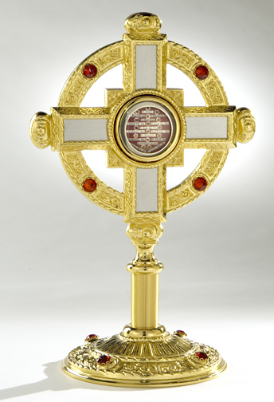
After the “Relics of the Passion” tour and the recent three year tour of the “OPERATION – Special Intentions” (Military Patrons) to military bases in the USA, Guam, Hawaiian Islands and the Philippines the ICHR announces the “Apostles – Foundation of our Faith” tour.
“Apostles - The foundation of our faith” tour has been created with the focus on educating the adult faithful and school children through public veneration and a well scripted lesson plan to the importance of the apostolic college.
Enclosed within a beautiful standing reliquary are relics of the Apostles and Evangelists; St. Peter, St. Thomas, St. Barnabas, St. Matthias, St. Jude Thaddeus, St. John, St. Andrew, St. Philip, St. Simon, St. Bartholomew, St. Paul, St. Matthew, St. James the less, and St. James the greater.
Handouts will be available (downloadable) for school children; discussed within will be the lives of the apostles and evangelists, how they suffered and willingly died for their faith, their patronages, their symbols in art, and the miracles they performed in the name of Christ. We will also have available a short classroom lesson plan, simple quiz, and a coloring page for the youngsters. We need to educate and evangelize and most of all provide Catholic materials for the faithful to take home.
The downloadable lesson and quiz will have an area for the children to write their personal information and prayer request. Each child who fills out the information and takes the simple quiz will be automatically enrolled in the “Friends of the Saints” club. The idea of this program is to educate the children prior to the arrival of the relics. Teachers will submit the information sheets to the ICHR representatives and the children will receive their membership cards.
Contact the ICHR for inclusion into the 2009 – 2010 U.S. schedules.
Contact: Tom@ICHRusa.com - www.ICHRusa.com - 1 818 416-9279

